**Installing MOST**

Requirements:

Java JRE 1.7

Gurobi jar file

For Windows:

Extract MOSTInstaller.zip, then double-click on MOSTInstall.exe file. The installer will open. The default install path will be filled in the Browse for installation folder text area.

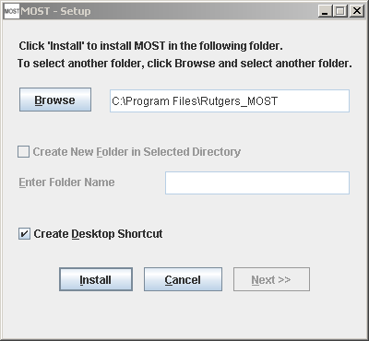

If the folder in the Browse for installation folder text field does not exist, create a new folder option will be disabled. In order to create a new folder, browse for an existing directory, such as Program Files, then check the “Create New Folder in Selected Directory” check box, and type the name of the folder into the “Enter Folder Name” text area.

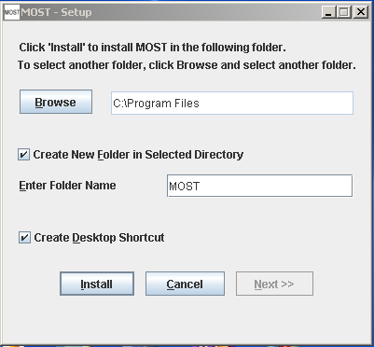

Click Install. The Installing message will appear:

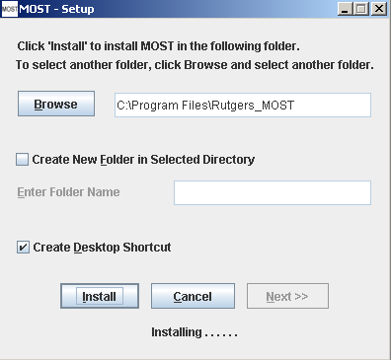

After MOST has been installed, the Next button will become enabled. Click the Next button to set up Gurobi.

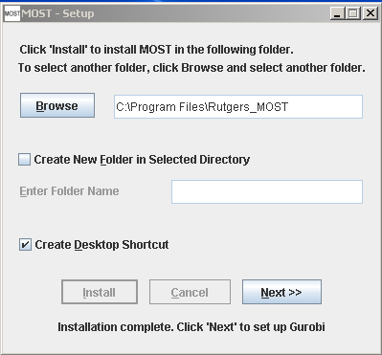

If the frame close “X” button is clicked at any time, the message below will appear:

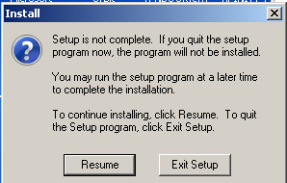

If this dialog is displayed after MOST has been installed, but Gurobi has not yet been set up, it is not necessary to run the installer again. Simply run MOST from the desktop icon or installation location (double-click MOST.exe) and the Gurobi Jar Path dialog will be displayed.

If MOSTInstaller .exe is run from a flash drive, the following error may be encountered when the Next button is clicked:

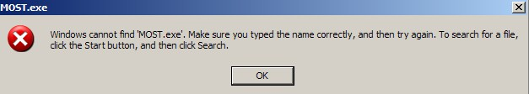

Click OK. Then open MOST as described above to set up Gurobi. The installation of MOST was successful.